**Design a Web service using Simple Object Access Protocol (SOAP)**

1.Create new dynamic web project and name it "SimpleSOAPExample".

[[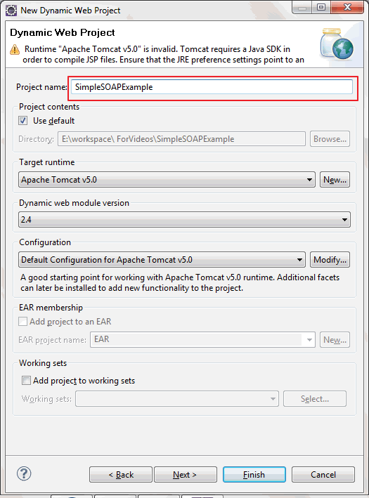](http://2.bp.blogspot.com/-_Ms8rDU8Rf0/UU4RhG5yAjI/AAAAAAAAA6k/V1oCx-SwiUE/s1600/NewProjectSOAPExample.gif)](http://2.bp.blogspot.com/-_Ms8rDU8Rf0/UU4RhG5yAjI/AAAAAAAAA6k/V1oCx-SwiUE/s1600/NewProjectSOAPExample.gif)

Create new package named "org.arpit.javapostsforlearning.webservices"

[i](http://1.bp.blogspot.com/-VDQx7-YVVXo/UU4RwYIT7PI/AAAAAAAAA6s/bA_xs1E89EQ/s1600/NewPackageSOAPExample.gif)

[[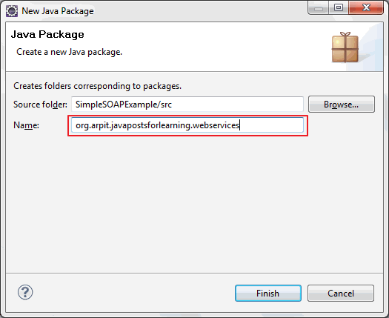](http://1.bp.blogspot.com/-VDQx7-YVVXo/UU4RwYIT7PI/AAAAAAAAA6s/bA_xs1E89EQ/s1600/NewPackageSOAPExample.gif)](http://1.bp.blogspot.com/-VDQx7-YVVXo/UU4RwYIT7PI/AAAAAAAAA6s/bA_xs1E89EQ/s1600/NewPackageSOAPExample.gif)

3.Create a simple java class named "HelloWorld.java"

[view plainprint?](http://www.java2blog.com/2013/03/soap-web-service-example-in-java-using.html)

1. **package** org.arpit.javapostsforlearning.webservices;
3. **public** **class** HelloWorld {
5. **public** String sayHelloWorld(String name)
6. {
7. **return** "Hello world from "+ name;
8. }
9. }

4.Right click on project->new->web service

[i](http://1.bp.blogspot.com/-6VwJVx0V1XI/UU4ShRAYHOI/AAAAAAAAA60/K8ANG-H-Dpk/s1600/newWebservice.gif)

[[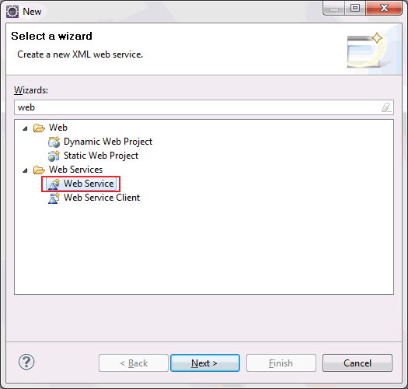](http://1.bp.blogspot.com/-6VwJVx0V1XI/UU4ShRAYHOI/AAAAAAAAA60/K8ANG-H-Dpk/s1600/newWebservice.gif)](http://1.bp.blogspot.com/-6VwJVx0V1XI/UU4ShRAYHOI/AAAAAAAAA60/K8ANG-H-Dpk/s1600/newWebservice.gif)

5.Click on next.

[[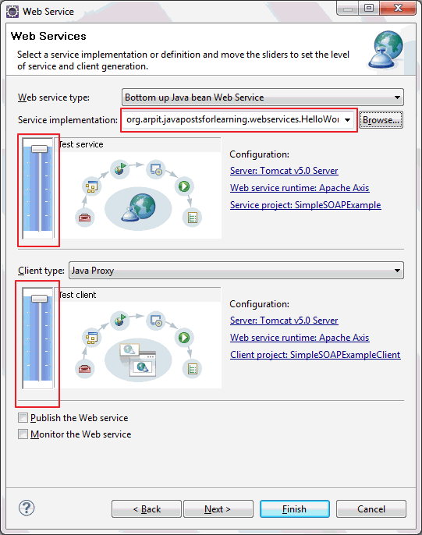](http://1.bp.blogspot.com/-BHas7nLGUDU/UU4SxVLHXbI/AAAAAAAAA68/GIXmmf4UAl4/s1600/WebServiceApacheAxis.gif)](http://1.bp.blogspot.com/-BHas7nLGUDU/UU4SxVLHXbI/AAAAAAAAA68/GIXmmf4UAl4/s1600/WebServiceApacheAxis.gif)

In service implementation text box, write fully qualified class name of above created class (HelloWorld.java) and move both above slider to maximum level (i.e. Test service and Test Client level) and click on finish. You are done!!A new project named "SimpleSOAPExampleClient" will be created in your work space.

[[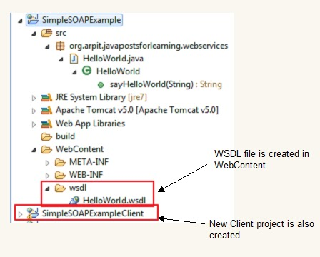](http://2.bp.blogspot.com/-7X4IiwtvBCc/UU4WLTU2ILI/AAAAAAAAA7M/JRM-SD6lsRw/s1600/SOAPClientCreated.bmp)](http://2.bp.blogspot.com/-7X4IiwtvBCc/UU4WLTU2ILI/AAAAAAAAA7M/JRM-SD6lsRw/s1600/SOAPClientCreated.bmp)

6.

[[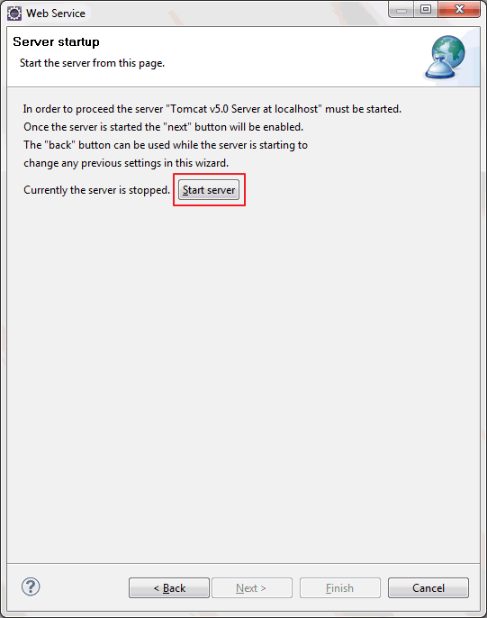](http://1.bp.blogspot.com/-aZBdfeyhP_A/UU4TiJTGkII/AAAAAAAAA7E/__2Gt9SrIDo/s1600/startServer.gif)](http://1.bp.blogspot.com/-aZBdfeyhP_A/UU4TiJTGkII/AAAAAAAAA7E/__2Gt9SrIDo/s1600/startServer.gif)

Click on start server.

7.After clicking start server, eclipse will open test web service API. With this test API, you can test your web service.

[[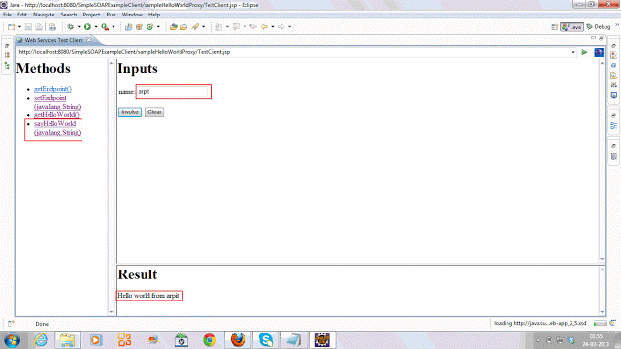](http://3.bp.blogspot.com/-aflUA272QuQ/UU4WtbqWpnI/AAAAAAAAA7U/hHOP1tRAvuA/s1600/testingWebService.gif)](http://3.bp.blogspot.com/-aflUA272QuQ/UU4WtbqWpnI/AAAAAAAAA7U/hHOP1tRAvuA/s1600/testingWebService.gif)